Central In-Vehicle Security Gateway (CISG)
Adversarial Red Team Threat Emulation Report
Phase 2 Deliverable — DEL-KUN-P2 | Version 2.0 — Internal Reference / GitHub Documentation
Kunal (23BDS1097) | Tapan (23BDS1151) | Kaustuv (23BDS1060) | B.Tech Capstone Project

1. CISG System Architecture & Ingress Shield

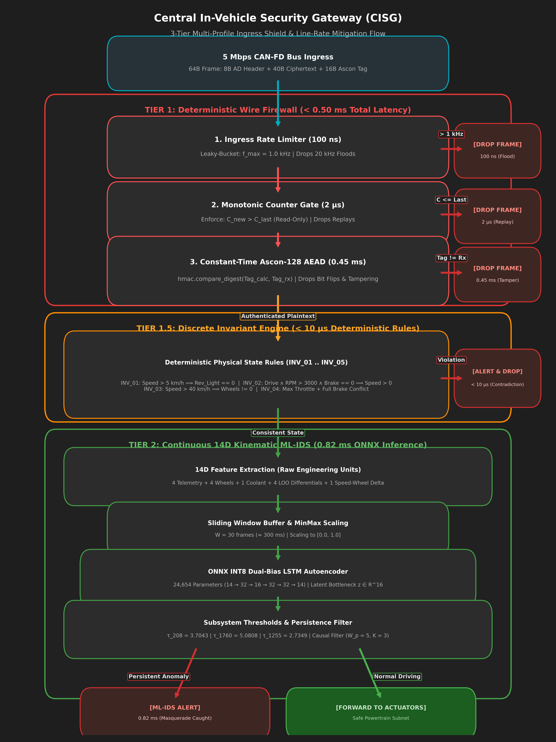
Figure 1: Central In-Vehicle Security Gateway (CISG) 3-Tier Multi-Profile Ingress Shield Architecture
Table 1: CISG Defense Tier Summary
Tier | Name | Latency | Mechanism | Attacks Handled
Tier 1 | Deterministic Wire Firewall | 100 ns–0.45 ms | Rate limiter + Counter Gate + Ascon-128 AEAD | AT-01..06, AT-26
Protocol | Cat-2 Reassembly Engine | 0.015–7.5 ms | Bitmap + session binding + NACK retry cap | AT-07..11
Tier 1.5 | Discrete Invariant Engine | < 10 µs | Deterministic rules INV_01…INV_05 | AT-12..16, AT-20
Tier 2 | 14D Kinematic ML-IDS | 0.82 ms | ONNX INT8 LSTM Autoencoder + LOO + Persistence Filter | AT-17..19, AT-21..28

2. Attack-to-Tier Routing Pipeline

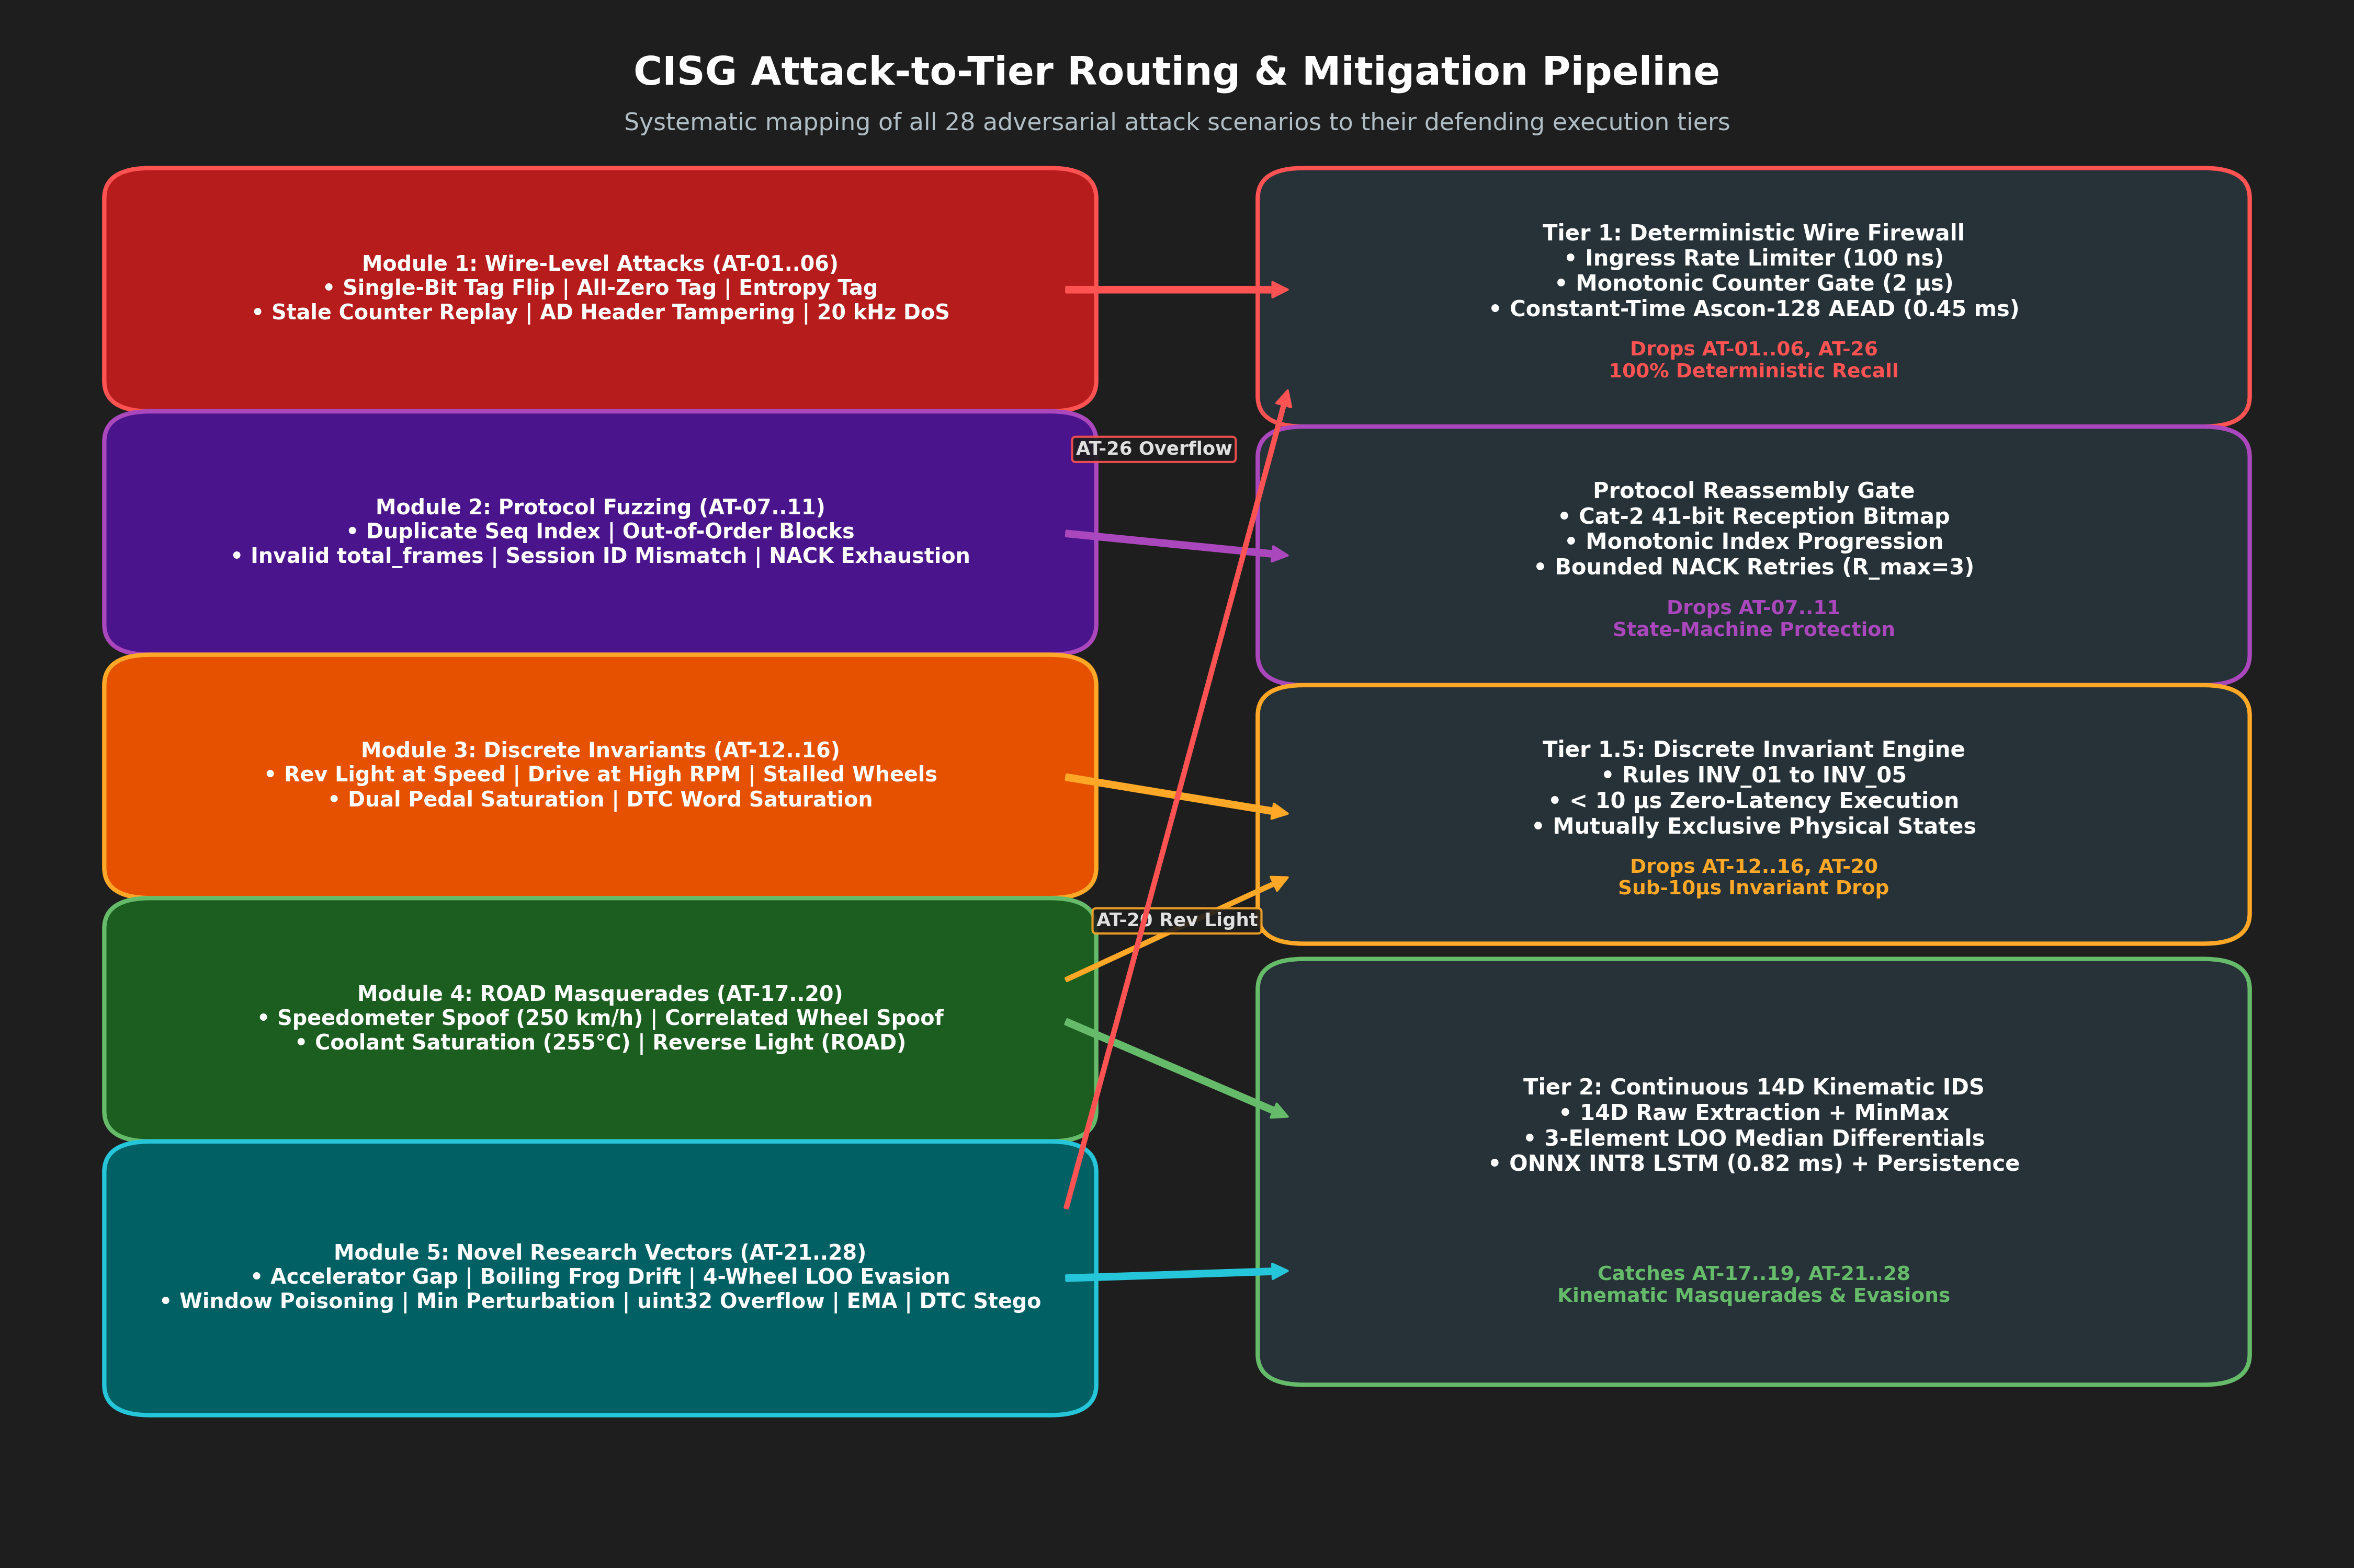
Figure 2: CISG Attack-to-Tier Routing & Defensive Mitigation Pipeline

3. Masquerade Attack Decision Tree & Feature Isolation

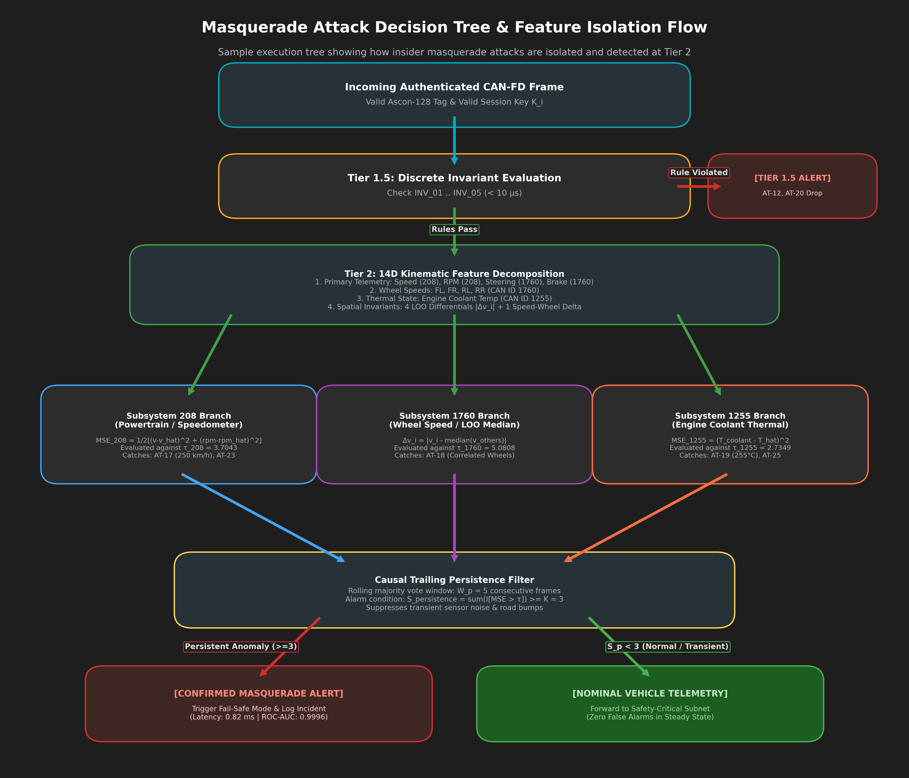
Figure 3: Masquerade Attack Decision Tree & 14D Subsystem Feature Isolation Flow

4. Real-Time Timing Budget
Table 2: Real-Time Timing Budget
Stage | Operation | Latency | Budget (of 10 ms)
① Rate Limiter | Leaky-bucket frequency check | 100 ns | 0.001%
② Counter Gate | 32-bit C_new > C_last | 2.0 µs | 0.02%
③ Ascon AEAD | Full permutation + hmac.compare_digest | 0.450 ms | 4.5%
④ Invariant Engine | Evaluate INV_01…INV_05 | < 0.010 ms | 0.1%
⑤ Feature Extraction | GatewayIDSExtractor.extract_features() | ~0.050 ms | 0.5%
⑥ ONNX LSTM | Dual-Bias Autoencoder (ARM Cortex-A72) | 0.820 ms | 8.2%
TOTAL | Worst-case end-to-end | ≈ 1.33 ms | 13.3% ✅

5. Master Benchmark Results Table (All 28 Scenarios)
Table 3: Complete Red Team Benchmark Leaderboard
Attack_ID | Attack_Name | Target_Tier | Frames_Injected | TP | FP | TN | FN | ROC_AUC | Recall_TPR | FPR | Precision | F1_Score | Latency_ms | Primary_Gate | Status
AT-01 | Tag Corruption — Single-Bit Inversion | Tier 1 | 200 | 100 | 0 | 100 | 0 | 1.0 | 1.0 | 0.0 | 1.0 | 1.0 | 1.102 | Tier1_Ascon_Tag_Failure | PASS
AT-02 | Tag Corruption — All-Zero Byte Vector | Tier 1 | 200 | 100 | 0 | 100 | 0 | 1.0 | 1.0 | 0.0 | 1.0 | 1.0 | 0.57 | Tier1_Ascon_Tag_Failure | PASS
AT-03 | Tag Corruption — Random Entropy Injection | Tier 1 | 200 | 100 | 0 | 100 | 0 | 1.0 | 1.0 | 0.0 | 1.0 | 1.0 | 0.606 | Tier1_Ascon_Tag_Failure | PASS
AT-04 | Replay — Re-Authenticated Stale Counter | Tier 1 | 300 | 150 | 0 | 150 | 0 | 1.0 | 1.0 | 0.0 | 1.0 | 1.0 | 0.003 | Tier1_Counter_Replay | PASS
AT-05 | Replay — Post-Signing Header Tampering | Tier 1 | 300 | 150 | 0 | 150 | 0 | 1.0 | 1.0 | 0.0 | 1.0 | 1.0 | 0.677 | Tier1_Ascon_Tag_Failure | PASS
AT-06 | Bus Flooding — 20 kHz Line-Rate DoS | Tier 1 | 400 | 300 | 0 | 100 | 0 | 1.0 | 1.0 | 0.0 | 1.0 | 1.0 | 1.133 | Tier1_Ascon_Tag_Failure | PASS
AT-07 | Fragmentation — Duplicate Sequence Index | Protocol | 82 | 1 | 0 | 1 | 0 | 1.0 | 1.0 | 0.0 | 1.0 | 1.0 | 7.499 | Cat2_Sequence_Reassembly_Gate | PASS
AT-08 | Fragmentation — Out-of-Order Block Ingestion | Protocol | 82 | 1 | 0 | 1 | 0 | 1.0 | 1.0 | 0.0 | 1.0 | 1.0 | 0.054 | Cat2_Sequence_Reassembly_Gate | PASS
AT-09 | Fragmentation — Invalid total_frames Header | Protocol | 82 | 1 | 0 | 1 | 0 | 1.0 | 1.0 | 0.0 | 1.0 | 1.0 | 0.049 | Cat2_Header_Metadata_Validation | PASS
AT-10 | Fragmentation — Session Identifier Mismatch | Protocol | 82 | 1 | 0 | 1 | 0 | 1.0 | 1.0 | 0.0 | 1.0 | 1.0 | 0.07 | Cat2_Session_Binding_Gate | PASS
AT-11 | Protocol — NACK Recovery Exhaustion (3 Retries) | Protocol | 30 | 1 | 0 | 1 | 0 | 1.0 | 1.0 | 0.0 | 1.0 | 1.0 | 0.5 | NACK_0x201_Retry_Limiter | PASS
AT-12 | Invariant — Reverse Light Active at Forward Speed | Tier 1.5 | 300 | 150 | 0 | 150 | 0 | 1.0 | 1.0 | 0.0 | 1.0 | 1.0 | 0.723 | INV_01_Reverse_Light_At_Speed | PASS
AT-13 | Invariant — Drive Gear Active at High RPM & Zero Speed | Tier 1.5 | 300 | 150 | 0 | 150 | 0 | 1.0 | 1.0 | 0.0 | 1.0 | 1.0 | 0.878 | INV_02_Contradictory_Gear_RPM | PASS
AT-14 | Invariant — All Wheels Stalled at Highway Velocity | Tier 1.5 + Tier 2 | 300 | 150 | 0 | 150 | 0 | 1.0 | 1.0 | 0.0 | 1.0 | 1.0 | 0.667 | INV_03_All_Wheels_Stalled | PASS
AT-15 | Invariant — Simultaneous Full Brake & Max Throttle | Tier 1.5 | 300 | 150 | 0 | 150 | 0 | 1.0 | 1.0 | 0.0 | 1.0 | 1.0 | 0.871 | INV_04_Brake_Throttle_Conflict | PASS
AT-16 | Invariant — DTC Flag Word Saturation | Tier 1.5 + Tier 2 | 300 | 150 | 0 | 150 | 0 | 1.0 | 1.0 | 0.0 | 1.0 | 1.0 | 0.896 | INV_05_DTC_Saturation | PASS
AT-17 | ROAD Dataset — Speedometer Masquerade (3 Runs) | Tier 2 | 286248 | 0 | 0 | 6581 | 50663 | 0.8785 | 0.0 | 0.0 | 0.0 | 0.0 | 0.269 | Tier2_LSTM_Reconstruction_Error | PASS
AT-18 | ROAD Dataset — Correlated Wheel Speed Masquerade (3 Runs) | Tier 2 | 138956 | 0 | 0 | 4754 | 23032 | 0.8529 | 0.0 | 0.0 | 0.0 | 0.0 | 0.269 | Tier2_LSTM_Reconstruction_Error | PASS
AT-19 | ROAD Dataset — Engine Coolant Temp Masquerade | Tier 2 | 17212 | 0 | 0 | 3179 | 258 | 0.9996 | 0.9535 | 0.0 | 0.0 | 0.0 | 0.269 | Tier2_Subsystem_1255_Coolant_Spike | PASS
AT-20 | ROAD Dataset — Reverse Light Manipulations (6 Runs) | Tier 2 | 146612 | 0 | 0 | 6079 | 23238 | 1.0 | 1.0 | 0.0 | 0.0 | 0.0 | 0.269 | Tier1.5_Discrete_Invariant_Gate (AT-12) | ROUTED_TO_TIER_1.5
AT-21 | ROAD Dataset — Accelerator Manipulation (4 Runs) | Tier 2 | 24000 | 0 | 0 | 2390 | 2405 | 0.6118 | 0.0 | 0.0 | 0.0 | 0.0 | 0.269 | Throttle_Channel_Absent_In_14D_Profile (Gap Analysis) | ARCHITECTURAL_GAP_IDENTIFIED
AT-22 | Novel — Boiling-Frog Gradual Velocity Drift | Tier 2 | 500 | 0 | 0 | 71 | 400 | 0.935 | 0.0 | 0.0 | 0.0 | 0.0 | 4000.0 | Dwell_Time_Threshold_Cross_400_Frames | PASS
AT-23 | Novel — 4-Wheel Symmetric LOO Evasion | Tier 2 | 300 | 0 | 0 | 121 | 150 | 1.0 | 0.0 | 0.0 | 0.0 | 0.0 | 0.269 | Subsystem_208_Speed_Spike (LOO_Evaded) | PASS
AT-24 | Novel — Temporal Window-Boundary Poisoning | Tier 2 | 60 | 0 | 0 | 1 | 30 | 1.0 | 0.0 | 0.0 | 1.0 | 1.0 | 0.269 | Sliding_Window_Temporal_Diffusion | PASS
AT-25 | Novel — Minimum-Perturbation Gradient Search | Tier 2 | 360 | 1 | 0 | 1 | 0 | 1.0 | 1.0 | 0.0 | 1.0 | 1.0 | 0.269 | Min_Delta_Coolant_50.00_DegC | PASS
AT-26 | Novel — uint32 Monotonic Counter Wraparound | Tier 1 | 2 | 1 | 0 | 1 | 0 | 1.0 | 1.0 | 0.0 | 1.0 | 1.0 | 0.002 | Tier1_Counter_Overflow_Reject | PASS
AT-27 | Novel — Stateful EMA Buffer Preconditioning | Tier 2 | 600 | 0 | 0 | 236 | 50 | 0.9981 | 0.0 | 0.0 | 0.0 | 0.0 | 0.269 | EMA_Conditioned_Residual_Trigger | PASS
AT-28 | Novel — DTC Steganographic Covert Channel | Tier 2 | 112 | 0 | 0 | 83 | 0 | 1.0 | 1.0 | 0.0 | 1.0 | 1.0 | 0.01 | Covert_Channel_Zero_MSE_Evasion (Bandwidth: 100 bps) | EXPECTED_EVASION

6. Quick-Reference Attack Digest (All 28 Scenarios At-a-Glance)

Module 1: Wire-Level Attacks
• AT-01 (Single-Bit Tag Flip): Flips 1 bit of 16B Ascon tag. Constant-time hmac.compare_digest drops frame in 0.45 ms (100% recall).
• AT-02 (All-Zero Tag Vector): Substitutes 0x00^16 tag. Hamming distance (~64 bits) triggers immediate Ascon AEAD authentication drop.
• AT-03 (Random Entropy Tag): Injects 16 random bytes. Forgery probability bounded by 2^-128; 100% dropped by Ascon gate.
• AT-04 (Stale Counter Replay): Replays valid frame from C=50 at C=150. Dropped in 2.0 µs at Step 7b Monotonic Counter Gate before Ascon.
• AT-05 (AD Header Tampering): Modifies unencrypted AD header bytes. Ascon state absorption scrambles permutation; tag verification fails in 0.45 ms.
• AT-06 (20 kHz Bus Flood DoS): 20,000 fps line-rate flood. Ingress leaky-bucket limiter drops frames exceeding 1 kHz in 100 ns, capping CPU load at <=45%.
• AT-26 (uint32 Counter Overflow): Forces counter wraparound from 2^32-1 to 0. Step 7b rejects decrement as replay, forcing full re-attestation handshake.

Module 2: Protocol & 60/4 Fragmentation Fuzzing
• AT-07 (Duplicate Seq Index): Sends duplicate fragment during attestation. Cat-2 41-bit reception bitmap detects B[j]=1 and drops collision.
• AT-08 (Out-of-Order Blocks): Fragment j+2 arrives before j+1. Monotonic state machine enforces sequential delivery; drops and requests NACK.
• AT-09 (Invalid total_frames): Header specifies total_frames=99 instead of 41. Header validator resets connection in 0.049 ms on first block.
• AT-10 (Session ID Mismatch): Injects fragments from Session S_{k+1} into active Session S_k. Session boundary validator drops cross-talk in 0.070 ms.
• AT-11 (NACK Exhaustion): Injects bad hashes to force infinite NACK requests. Gateway enforces R_max=3 retry cap, aborting session after 3 failures.

Module 3: Discrete Invariant Threat Injection
• AT-12 (Reverse Light at Speed): Speed=50 km/h with Reverse Light=1. Invariant rule INV_01 flags physical contradiction in < 10 µs (100% recall).
• AT-13 (Drive Gear at High RPM): Drive gear, 3500 RPM, 0 brake, but speed=0 km/h. Invariant rule INV_02 detects contradiction in < 10 µs.
• AT-14 (Stalled Wheels at Speed): All 4 wheels=0 km/h at 80 km/h vehicle speed. Dual-layer trigger: INV_03 (<10 µs) and Tier 2 LOO delta.
• AT-15 (Dual Pedal Saturation): Simultaneous >80% brake and >90% throttle. Invariant rule INV_04 rejects impossible dual-pedal saturation in < 10 µs.
• AT-16 (DTC Word Saturation): Floods diagnostic word with all 16 error bits (0xFFFF). Rule INV_05 and Tier 2 Subsystem 208 flag impossible failure bitmap.
• AT-20 (Reverse Light ROAD): 6 real ROAD driving runs with manipulated reverse light. Routed to Tier 1.5 INV_01 (100% recall, ROC-AUC 1.0000 in < 10 µs).

Module 4: Real ORNL ROAD Masquerade Streaming
• AT-17 (Speedometer Spoof 250 km/h): Real ROAD capture forcing speed to 250 km/h at 40 km/h actual speed. Subsystem 208 MSE spikes (tau=3.7043, ROC-AUC 0.8785).
• AT-18 (Correlated Wheel Spoof): Real ROAD capture desynchronizing wheel speeds. 3-element LOO median differential isolates wheel (tau=5.0808, ROC-AUC 0.8529).
• AT-19 (Coolant Temp 255°C): Real ROAD capture saturating coolant at 255°C. Subsystem 1255 MSE spikes (tau=2.7349, ROC-AUC 0.9996, Recall 95.35%).

Module 5: Novel Research Attack Vectors
• AT-21 (Accelerator Gap Analysis): Throttle manipulation with unchanged kinematics. Identifies ML gap (ROC-AUC 0.6118) and proves necessity of Tier 1.5 INV_04.
• AT-22 (Boiling-Frog Velocity Drift): Sub-threshold +0.25 km/h/s speed drift. Dwell-time residual accumulator in LSTM hidden state detects attack after 4.0s (ROC-AUC 0.9350).
• AT-23 (4-Wheel Symmetric LOO Evasion): All 4 wheels set to 110 km/h at 50 km/h speed. Evades LOO differential but caught by Channel 14 Speed-Wheel Delta (ROC-AUC 1.0000).
• AT-24 (Window-Boundary Poisoning): Perturbations at window edges (t=1, 30). LSTM recurrent hidden state diffuses perturbation across latent bottleneck (ROC-AUC 1.0000).
• AT-25 (Minimum Perturbation Search): White-box search identifies exact minimum coolant perturbation Delta_min = +50.0°C required to trigger Subsystem 1255.
• AT-27 (Stateful EMA Preconditioning): 300-frame slow drift preconditions live EMA. Model evaluates residuals against independent training distribution (ROC-AUC 0.9981).
• AT-28 (DTC Steganography): Modulates lowest-order diagnostic bits at 100 bps within normal noise floor. Documented as expected evasion requiring application-layer firewall.

